LINKS TO REFER FOR 2ND ASMNT

1. IMORTANT

<http://www.makeuseof.com/tag/mobile-social-networks-friend/>

Geo-location technology is a hot topic as of late. We now have the ability to utilize the power of GPS right from the palm of our hand using our mobile device. We can view maps, points of interest, play games, and even spend time finding your friends via GPS with smart applications.

Being able to locate your friends without having to call them is a major bonus. And since we’ve become so adept at using social networks anyway, this is just one more tool added to the toolbox. Want to be able to find your friends even if you can’t hear them? If you want to locate their position (or give them yours) these 9 applications should help.

Before we get into the apps I would like to mention that we have written a few great articles in the past on this subject. For some more great location apps that won’t be covered here, I suggest you check out Beth’s article, [**The 9 Best iPhone GPS Apps**](http://www.makeuseof.com/tag/9-iphone-gps-apps-case-lost/), and Ryan’s [**5 Mobile Social Networks That Know When Your Friend Is Near**](http://www.makeuseof.com/tag/mobile-social-networks-friend/) and [**How To Trace a Mobile Phone Location with Google Latitude**](http://www.makeuseof.com/tag/how-to-trace-a-mobile-phone-location-with-google-latitude/).[**The 9 Best iPhone GPS Apps**](http://www.makeuseof.com/tag/9-iphone-gps-apps-case-lost/) [**The 9 Best iPhone GPS AppsREAD MORE**](http://www.makeuseof.com/tag/9-iphone-gps-apps-case-lost/)

### [****LOCiMOBILE****](http://locimobile.com/) ****[iPhone & Android]****

LOCiMOBILE has a few great GPS tracking apps out at the moment. The two that I would like to feature are the free/lite versions of the software.

### ****GPS Tracking Lite****

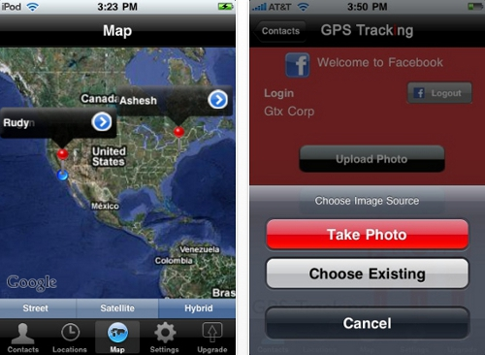

This app supports up to 6 users (paid version is unlimited) and integrates with Twitter and Facebook. GPS Tracking populates your phone’s built-in Google Maps with the locations of people in your private opt-in buddy list. You can let users know where you are or request their location, and you can post your information to your social profiles.

Advertisement

### ****iLOCi2 Lite****

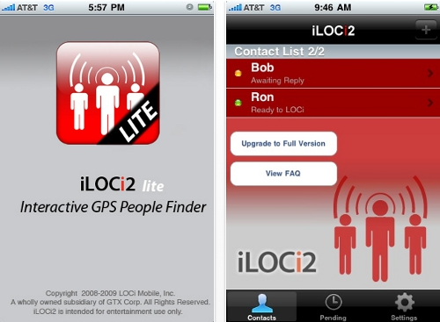

iLOCi2 is the “Interactive GPS People Finder.” Add people to your contact list and you can receive their location through notification alerts.

The app seems like a simpler version of GPS Tracking that is focused more on keeping your contact information organized. This app works in the background as well.

### [NO LONGER WORKS] ****Loopt**** ****[iPhone, Blackberry, Android & More]****

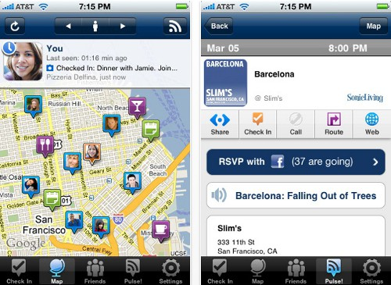

We’ve covered Loopt briefly in the past through a directory listing. Loopt is perfect for finding your friends via GPS and to learn what they’re doing. You can discover events or places around you or your friends with Loopt Pulse, as well as check in to places and share directions.

Loopt runs on over 100 [NO LONGER WORKS] phones.

### ****Mobcast**** ****[iPhone & Web Browser]****

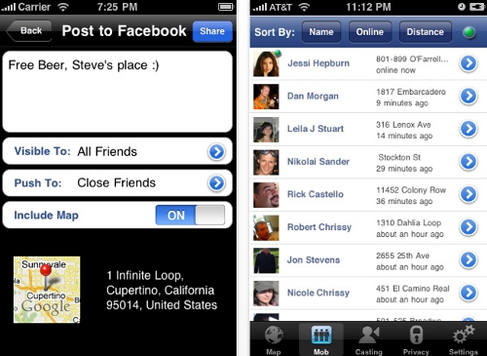

Mobcast is a Facebook application that lets you meet up with your friends without calling back and forth. View your friends’ locations on a map and post “mobcasts” which update your Facebook status with your location and push notifications to your friends.

Since the app is integrated with Facebook, there is no need to add your friends. You can also use this application from any web browser simply by signing in.

### [****Friends Around Me****](http://www.friendsaround.me/) ****[iPhone & iPad]****

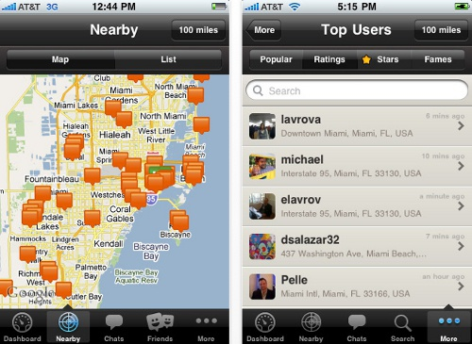

Use Friends Around Me to interact with friends across social networks and meet new friends based on a location-based search. Features include a free group chat, open profiles with alerts, integration with social networks like Facebook and Twitter, and a rewards system.

### [****HeyWAY****](http://niftybrick.com/heyway.html) ****[iPhone]****

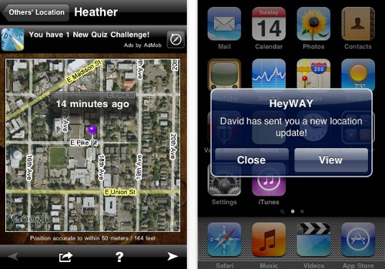

HeyWAY stands for Hey Where Are You. HeyWAY emphasizes privacy by making you individually authorize others to see your location. You can also choose when you want to receive updates. The app also logs location updates so you can refer back to your friends’ locations whenever you want.

### [****Find My Friend****](http://apps.facebook.com/findmyfriendiphone/) ****[iPhone]****

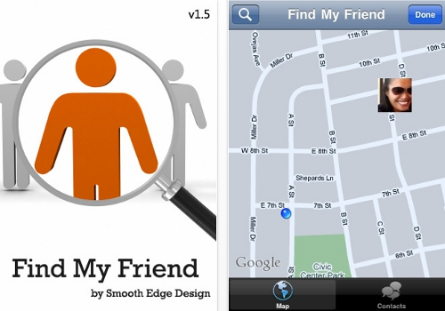

Find My Friend is a Facebook app, which means it cannot be used if you don’t have a Facebook account. The main purpose of the app is to be able to meet up with your friends without having to tell each other where you are. It is integrated with Facebook and you have the ability to accept/reject requests. Privacy is taken into account with this app.

### [****Friend Mapper Free****](http://www.amigomapper.com/) ****[iPhone]****

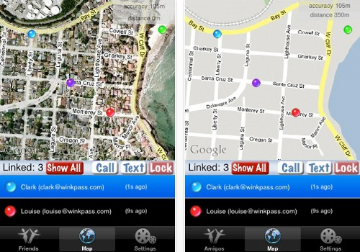

Friend Mapper updates your position live every 15 seconds. You can hide your position at any time. One-touch call or text your friends and view their locations. The time of their last update is noted.

The free version of this app only allows you to view one friend’s location, however. The paid version (99 cents) allows up to 23 streams simultaneously.

### ****GeoTwitts**** ****[iPhone]****

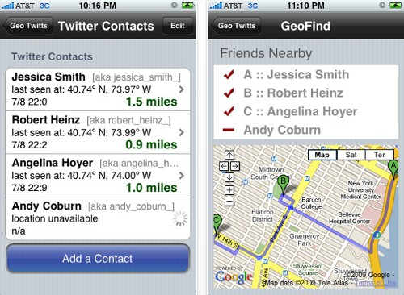

GeoTwitts posts your GPS location to Twitter. It also reads your friends GeoTwitts and gives you their location, along with directions to them if you would like to meet up. The app uses Google Maps to monitor/display directions and navigation.

### ****Conclusion****

4With these apps installed on your mobile device, finding your friends via GPS should be easy.

Have you used any of these apps before? Are there any geo-location apps you use that I didn’t cover? Leave your thoughts, ideas, and comments below!

One of the most amazing things about being involved in the Internet since its inception is watching its evolution throughout the decades. From the early days of sending electronic notes to the ability to send instant messages to allowing people to communicate with large groups of people like never before, the Internet continues to transform the world we live in.

As the world crossed over beyond 2000 and more people adopt SmartPhones so that they’ll have constant access to their favorite social networks and email – I often wonder how this will impact the continued evolution of the Internet. One area that I believe is teetering on the brink of explosive growth are location-based, free mobile social sites that let you both share your location and see the location of your friends.

### Top 5 Mobile Social Networks To See Friend Locations

While it’s nearly impossible to predict the failure or success of particular players within a brand new niche like this (does anyone still use AOL for Internet access anymore?) it is at least possible to take a momentary snapshot of who those players are in the area of free mobile social sites. At the start of any new technological trend, there are often a mix of large and small players. After a while a powerhouse eventually achieves the widest user-base – a few examples: Microsoft Windows, Google and Facebook.

Those who are disappointed in the overwhelming choice of the masses – you should probably take a more active role in making use of those technologies while the technology is new.  Once any single free mobile social site gets a solid foothold with a substantial enough user base, group-think takes over and everyone else jumps on the bandwagon. If you feel strongly about a particular player here, then sign up and actively use the service. Encourage friends and family to use it and before you know it, your choice may very well be the app of choice for everyone.

### Google Latitude

Of course, the Google solution, [**Google Latitude**](http://www.google.com/latitude/intro.html), which I wrote about earlier [**here at MakeUseOf**](http://www.makeuseof.com/tag/how-to-trace-a-mobile-phone-location-with-google-latitude/), was an early contender in this location-based mobile social network race.[**How to Trace a Mobile Phone Location With Google Latitude**](http://www.makeuseof.com/tag/how-to-trace-a-mobile-phone-location-with-google-latitude/) [**How to Trace a Mobile Phone Location With Google LatitudeREAD MORE**](http://www.makeuseof.com/tag/how-to-trace-a-mobile-phone-location-with-google-latitude/)

Advertisement

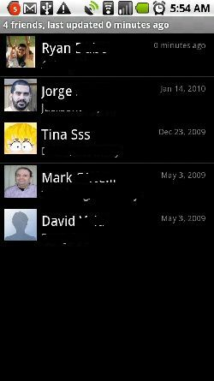

With Latitude, you don’t technically join a social network. Instead you build your own private social network from the ground up, based on the friends you have who are also running Latitude and keep it active on their phone. As you can see, my friend Jorge runs Latitude fairly often – his last updated location was January 14th. My buddy Mark chickened out back in May of last year and hasn’t updated his location since!

By the way, while there’s no Latitude “social network” per se, there is the option to add your “Latitude Badge” to your favorite social network or blog and share out your GPS location to the entire world (if you dare).

### The Gypsii Social Network

The next mobile social network that I’d like to cover is Gypsii. So far, this is actually my favorite one – and I believe that it is soon to enter into the leader’s circle for best location-based social networks. There are lots of mobile social networks out there – or mobile plugins for online social networks, but the coolness factor from a social network like Gypsii is that every member is automatically location-identified. This means you immediately know where potential friends are located around you.

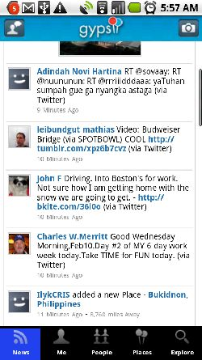

The “News” page shows all of the public Gypsii status updates – much like how Twitter works. As you can see, there’s already a decent base of worldwide users that are active on Gypsii – but it still has a very long way to go.

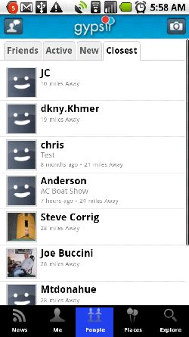

In my mind, the true test of such a social network would be how many members exist around me. I live in a remote location in Southwestern Maine – essentially “hicksville” – and not a whole lot of tech-savvy folks in the neighborhood.

Clicking on the “People” tab and searching for members who are closest to me, I was pleasantly surprised to see about 10 or so folks in the network located within 30 miles from me, and even one who just lives 10 miles away. As you can see, there’s a “friends” tab where you can view just the friends on your contact list, if you so wish.

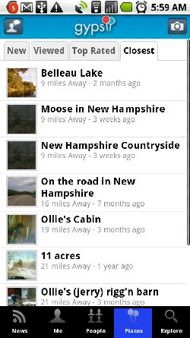

The coolest feature of the Gypsii mobile social network, in my humble opinion, is the “Places” tab. Here, you can review images uploaded to Gypsii. This isn’t unique among social networks, but what is unique is the fact that you can isolate the images based on members who are closest to your location – and review some very cool personal photos for places around you. This would be very useful during a vacation, to see certain places and attractions and determine if it’s worth your while.

### Match Up With People At Match2Blue

Another location based mobile social network is [**Match2Blue**](http://www.match2blue.com/). Match2Blue is a much more scaled down application (at least on the Android), with basic functionality like searching for people near you, adding those people to your contact list and sending messages.



The main page shows a listing of all members, which you can view by proximity to you. Upload your photo and start updating your status with tempting messages to attract your future mate. As you can see – most of the status updates are folks doing just that. This is very much a mobile social network for dating.

### The Exciting (But Empty) Centrl Social Network

Centrl is another new contender in this market. It’s a New York based startup, and I believe there’s a lot of promise – but it really needs to develop a user base as quickly as possible if it’s going to compete with the other new kids on the block.

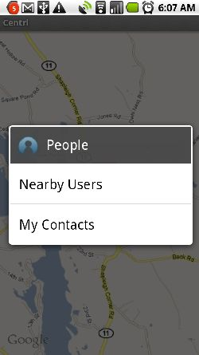

The moment you sign in, you can either invite your own contacts to the network, or you can see what other users are near you.

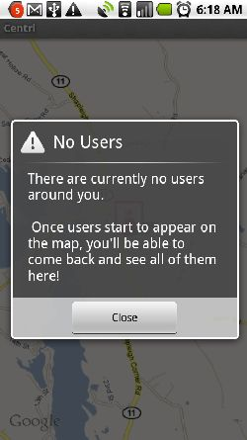

As you can see, I didn’t have much luck. However, I like the fact that once there are other users, it won’t just show them as “near you,” but it’ll overlay their position onto Google Maps – just like Google Latitude. On the other hand, this accuracy may be a turn-off for many potential users who may have privacy concerns.



You can see from the public chat area that the social network itself isn’t completely abandoned – but it’s just in the beginning phase of building up a solid network of users. If you live in or around a larger city, it may have more usefulness to you in its present state.

### Give Your Social Network a Glympse

I wanted to share one more mobile app called **[Glympse](http://www.glympse.com/)**. This one isn’t so much a location based social network, as it is a location based notifier for your friends and contacts.

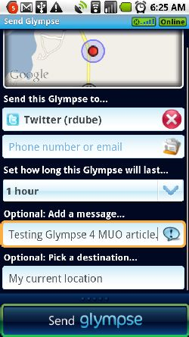

Using the service is very simple. Instead of constantly sharing out your location publicly, you can instead send out a public glimpse of your location when you want to share it. You can send the update to your friends via SMS or email or (and this is my favorite feature) you can send it to Twitter.

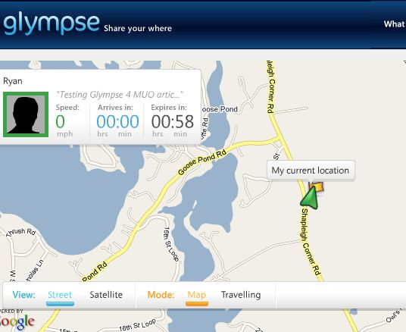

Sending your “glympse” to Twitter posts your comment plus a link to your Glympse page where people can see your location. The great part of this is that the location is only accurate for the amount of time you set. Glympse basically lets you turn Twitter itself into a location based social network.

Do you know of any other cool location based social networks that you can access from your mobile phone? Share them in the comments section below.